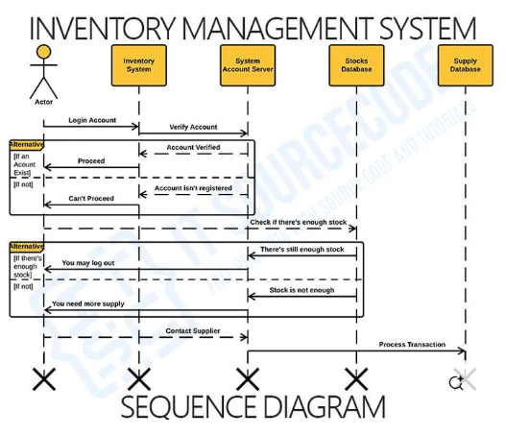

**PRACTICAL NO.07**

sequence diagram for an **Inventory Management System (IMS)** for a small-scale business involves illustrating how different components interact to perform the primary functions of the system, such as tracking stock levels, updating inventory, and generating reports.

**Actors:**

1. **User (Business Owner/Employee)**
2. **System (Inventory Management System)**
3. **Database** (Stores the inventory data)

**Main Use Case:**

1. **View Inventory**
2. **Update Stock (Add/Remove Items)**
3. **Generate Inventory Report**
4. **Receive Stock (Purchase Order)**

**Sequence Diagram Steps:**

1. **View Inventory:**
   * **User** requests to view the current inventory.
   * **System** queries the Database for the list of products and their stock levels.
   * **Database** sends the inventory data (product details) back to the System.
   * **System** displays the inventory to the User.
2. **Update Stock:**
   * **User** inputs the product details (product ID, quantity, action: add/remove).
   * **System** validates the input (checks if the product exists).
   * If add action, the System updates the Database by increasing the stock.
   * If remove action, the System checks the stock level to ensure there is enough quantity, then decreases the stock in the Database.
   * **System** confirms the update to the User.
3. **Generate Report:**
   * **User** requests to generate an inventory report (e.g., current stock, low-stock items).
   * **System** queries the Database for relevant inventory data.
   * **Database** sends the requested data back to the System.
   * **System** generates and displays the report to the User.
4. **Receive Stock (Purchase Order):**
   * **User** places a purchase order (product ID, quantity) to receive new stock.
   * **System** verifies the order and updates the Database to reflect the new stock levels.
   * **System** sends confirmation of the received stock to the User.